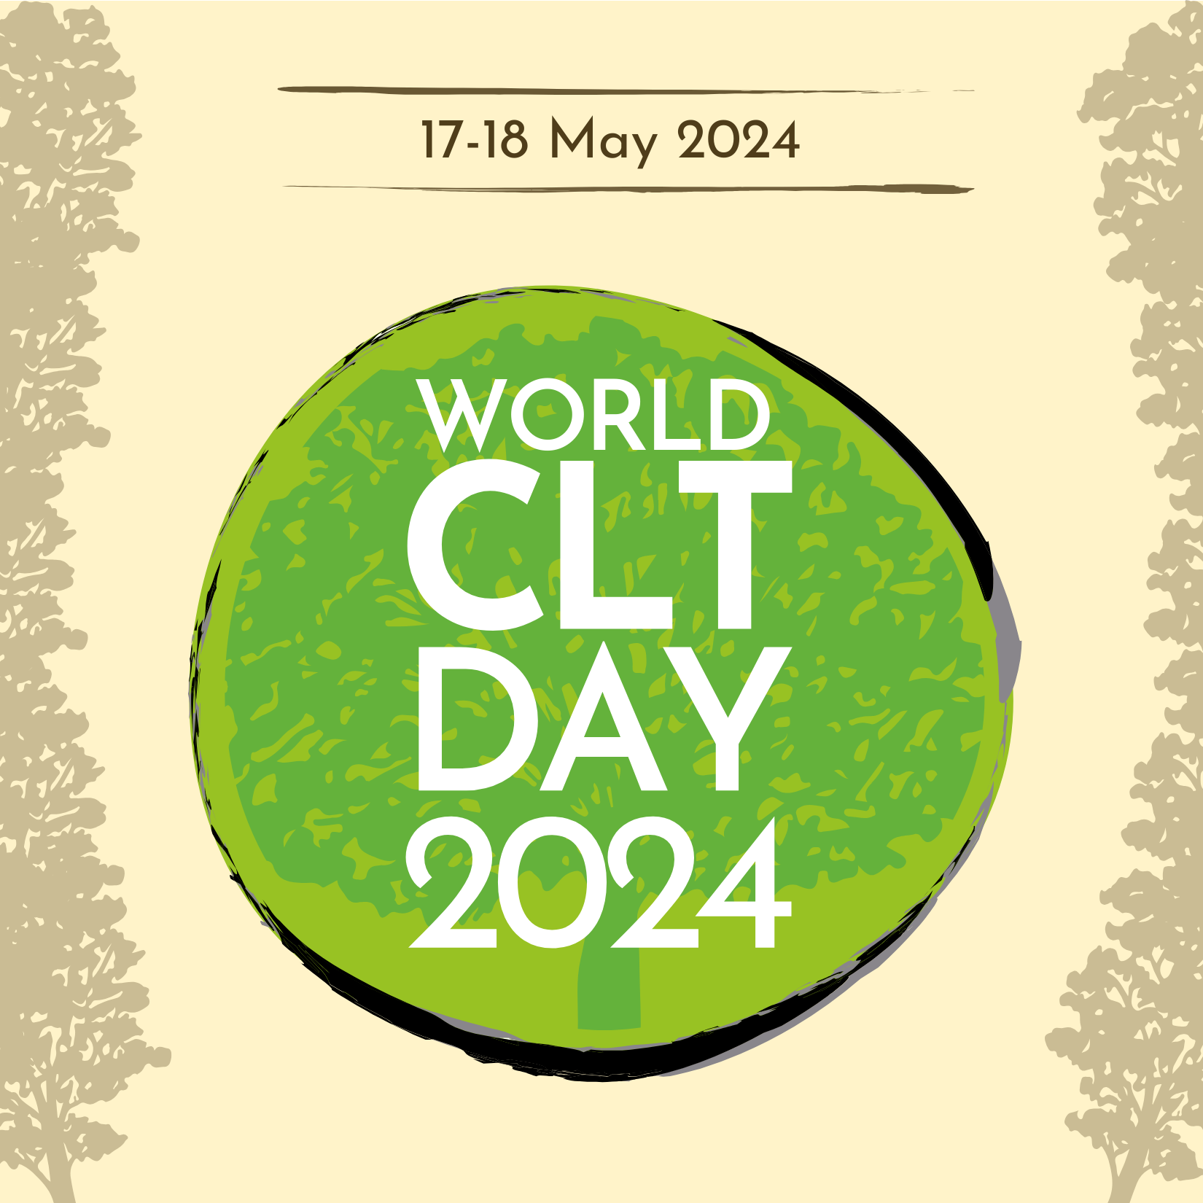
World CLT Day Branding Information

Color sample | HEX Code | Color name
 | #FFF3C9 | Beige
 | #98C223 | Light green
 | #119961 | Dark green
 | #89868B | Gray
 | #4E3C19 | Brown
 | #000000 | Black

Fonts:
- Poster Fonts:
  - Josefin Sans Bold ("CLT DAY")
  - Josefin Sans Regular ("World", "2024")
- Website Font:
  - Source Sans Pro

